

**A VIRTUAL LEARNING COLLABORATION SYSTEM.**

**SYSTEM DOCUMENTATION**

**SUBMITTED BY,**

**WESLEY KAMOTHO NGOMI**

**DCS-03-8392/2023**

**A SYSTEM DOCUMENTATION SUBMITTED IN PARTIAL FULFILMENT FOR THE AWARD OF DIPLOMA IN COMPUTER SCIENCE BY ZETECH UNIVERSITY**

**APRIL 2025**

**DECLARATION**

***Leave this section blank until you’ve done the rest of the document***

*A paragraph saying that the project has been done by you, has not been outsourced from somewhere, and that this documentation has also been prepared by you, then leave a section like below for signing.*

Student Name: ____________________________ Sign: _________________ Date: __________

Supervisor Name: _________________________ Sign: _________________ Date: __________

**DEDICATION**

***Leave this section blank until you’ve done the rest of the document***

*Say who you want to dedicate your project to (could be a parent, a loved one, or a mentor)*

**ABSTRACT**

***Leave this section blank until you’ve done the rest of the document***

*A summary of the project (how long it took, what tools/technologies/programming languages/frameworks/database technologies you’ve used. For what purpose has the project been built – to solve what problem and what you have achieved.)*

**DEFINITION OF KEY TERMS**

***Leave this section blank until you’ve done the rest of the document***

*Each key word you’ve used in this document and what it means, listed in alphabetical order e.g.*

**Database:** a central repository for data

**Webpage:** a single page containing particular information of the website e.g. a contact page, built to be accessed from a browser.

**ABBREVIATIONS AND ACRONYMS**

***Leave this section blank until you’ve done the rest of the document***

*Here, list down all short forms you’ve used in this document, with their meaning in full, and arranged in alphabetical order e.g.*

**HTML –** Hyper Text Mark Up Language

**SQL –** Structured Query Language

**LIST OF FIGURES**

***Leave this section blank until you’ve done the rest of the document***

*Here, list down all the image captions you have in your document, and in the correct order in which they appear in the document, from start to end e.g.*

Fig 3.1-1 Login Page

Fig 3.1-2 Sign Up Form

Fig 3.2 Cart Management Code

**LIST OF TABLES**

***Leave this section blank until you’ve done the rest of the document***

*Here, list down all the table captions you have in your document, and in the correct order in which they appear in the document, from start to end e.g.*

Table 1.2 Functional Requirements

Table 1.3 Budget Breakdown

**TABLE OF CONTENTS**

***Leave this section blank until you’ve done the rest of the document***

Generate a table of contents for your document. Here is a quick guide on how to do that: <https://www.youtube.com/watch?v=0cN-JX6HP7c&t=87s>

**CHAPTER ONE: PROJECT PLANNING AND ANALYSIS**

* 1. **Statement of Problem**

Learners often feel the need to come together to share different perspectives on different topics , but aspects such as being on different geographical location, locating a conducive environment able to foster their academic curiosity. This can leave Learners unmotivated and unwilling to participate in collaborative learning.

* 1. **Study Justification**

The virtual learning collaboration system is here to remedy this situation by allowing and nurturing collaborative learning on an e-learning level thus making sure all a learner needs to get in on the action is a good internet connection. Through a combination of various technologies, the system will provide a conducive virtual space always ready to serve curious minds.

* 1. **System Objectives**
     1. **General Objective**

1. To develop a virtual learning collaboration system.
   * 1. **Specific Objectives**
2. To implement authorization and authentication mechanisms through user accounts to facilitate access to the system for the users.
3. To implement authorization and authentication mechanisms through user accounts to facilitate access to the system for the users.
4. To implement sessions through which user tasks like quizzes can be created and video conferencing be facilitated.
5. To allow users to upload pdf documents to be discussed during the collaborative sessions.
6. To store, retrieve and protect user data through implementation of a secure and efficient database.
   1. **Functional Requirements**

*(This is already in your workplan)*

|  |  |  |
| --- | --- | --- |
| **User** | **User Activities** | **Features** |
|  |  |  |
|  |  |  |
|  |  |  |
|  |  |  |

**Table 1.4 Functional Requirements Table**

**CHAPTER TWO: DESIGN AND MODELING**

*Transfer all the diagrams you used to design your system during milestone 3, to this chapter. Explain each diagram, have the diagram below the explanation, and a caption below the diagram*

**2.1 Introduction to Modelling**

*A paragraph telling the reader that in this chapter they’ll find designs and models that you drew to help you visualize the system before you started the development work, and the benefit you got from modelling your system before developing.*

**2.2 User Interface Models**

*Diagrams of all the forms, pages, reports, windows, dialog boxes, interaction panels for users that you hand-sketched to visualize how they would look like before developing.*

*Organize them into subheadings e.g. 2.2.1 Login Page Design, 2.2.2 Sign Up Form Design, 2.2.3 Products Page Design. In each subheading, have the hand-sketched / Figma-sketched design of that UI, and a caption underneath it e.g. Fig 2.2.1 Login Page Design, Hand-Sketched.*

**2.3 Logic Models**

**2.3.1 Usecase diagram.** 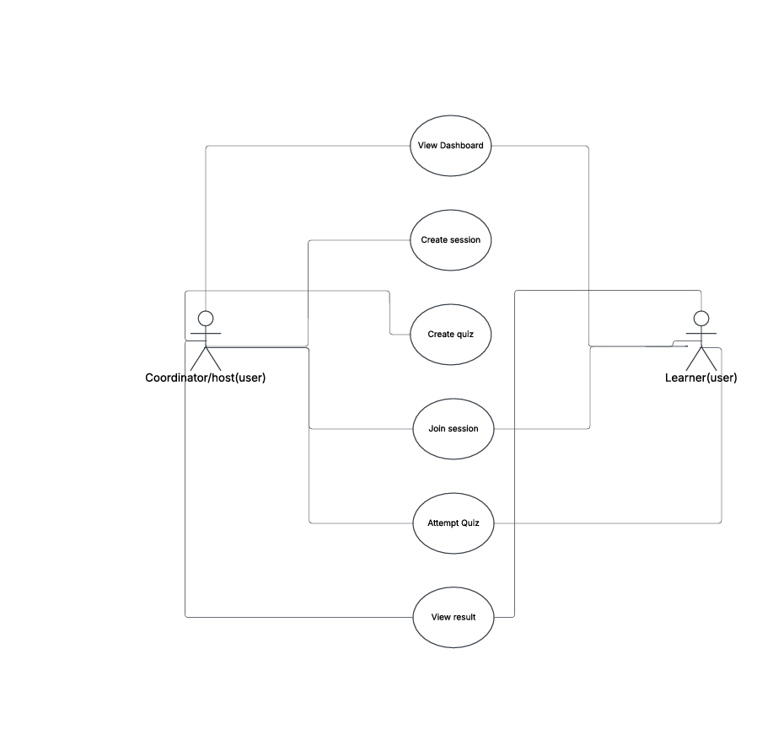

**2.3.2 Flowchart.**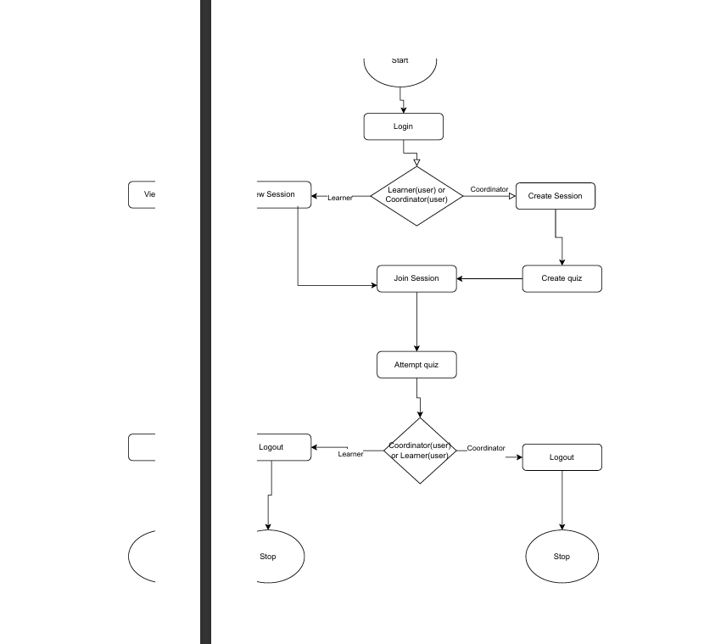

**2.3.3 ERD diagram.**

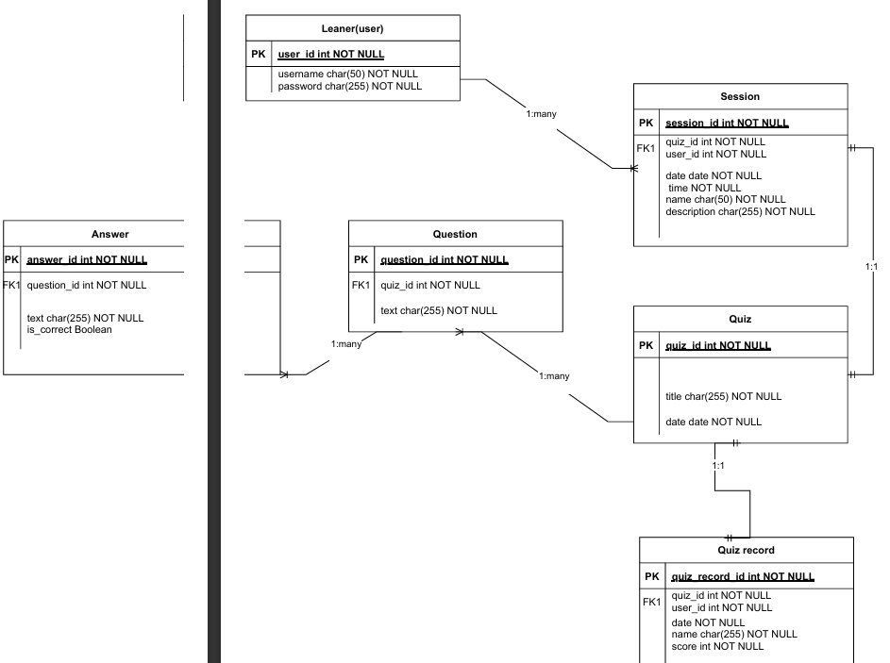

*Diagrams of all the process architecture diagrams that you sketched to visualize how the system will work e.g. flowcharts, class diagrams, sequence diagrams, data flow diagrams, decision trees, etc..*

*Organize them into subheadings e.g. 2.3.1 Login Process Flowchart, 2.3.2 Purchase/Checkout Process Flowchart, 2.3.3 Class Diagram for the System, 2.3.4 From Enquiry Making to Enquiry Reply Flowchart*

*In each subheading, have the hand-sketched (or if you’ve used a drawing tool) design of that diagram, and a caption underneath the diagram*

**CHAPTER THREE: SYSTEM IMPLEMENTATION**

**(DEVELOPMENT, TESTING AND DEPLOYMENT)**

*This is where you report on your development journey e.g. from when you downloaded your IDEs, and coding, to implementing your database to deploying your system*

**3.1 Introduction**

*A paragraph telling the reader what they expect to see in this chapter – a journey of your development*

**3.2 User Interface Development**

*Your system has two sides – the user side (where different users can interact with the system) and the logic side.*

*Under this section you will screenshot all the User Interfaces you have built (login pages, sign up forms, report page, dashboard, etc.) and the code for them if you built them from scratch, e.g. a screenshot of the html and css code for sign up form.*

*Organize them into subheadings e.g. 3.2.1 Login Page Development (under this section, a brief explanation of what it’s been built for, a screenshot of the page and a caption underneath it, screenshots of its html and css code used to develop it, and captions underneath every screenshot)*

**3.3 Logic Development**

*Your system has two sides – the user side (where different users can interact with the system) and the logic side. The logic side is how the system is performing activities using data e.g. login validation, processing checkout and generating a receipt, storing data into database, retrieving products from DB and showing them on a certain page. This is called logic.*

*Under this section you will screenshot all the* ***Codes*** *that handle different processes/activities. Organize them into subheadings e.g. 3.3.1 Login Validation Code (herein, explain in brief how the system handles login, take screenshots of the login validation code, and caption it)*

**3.4 Testing**

*Detail out what actions you took to test whether different features of your system are working. And corrections you made to different parts to ensure that they are working as planned.*

**3.5 Deployment**

*Say on what platforms did you deploy your system (e.g. if it’s a website, what web hosting platform did you use – and copy paste a link to your website, if it’s an android application – the process of putting up your app on Google Playstore.). Essentially, detail out the process of how you converted your project into a form that can be run/installed by anybody.*

**CHAPTER FOUR: CONCLUSION AND RECOMMENDATION**

**4.1 Conclusion**

*A paragraph summarizing chapter one, two and three. And finish by telling us what new things you learnt during the entire time developing your project, and challenges faced.*

**4.2 Recommendation**

*Here, speak as if addressing another developer of the same project you’ve been working on. Suggest to him/her things that they can do to improve the system if they so choose to pick it up and enhance it. E.g. if you created an e-receipt for customers, suggest to him/her to consider integrating a physical receipt printer since some customers would prefer that and also you couldn’t implement that because you didn’t have the budget for a printer. If your system is a staff clock-in-and-out system and in your system a staff has to type in their staff number into the system, suggest to the developer what better technologies he/she can use to enhance that specific part e.g. biometric or swipe-card, maybe since you did not have the budget to buy those devices and/or didn’t have the technical skills for that. Or if for payment your system is using Pay-After-Delivery, suggest to him/her to consider integrating with MPESA or Bank Card for pre-delivery payments.*

***NB: Recommendation is not an excuse for a NOT WORKING system, e.g. it is not saying that your system can’t store any data because you didn’t have the time to implement a database, No. It is a suggestion for how your ALREADY WORKING SYSTEM (with the lower technologies you’ve used) can be MADE BETTER, with HIGHER/BETTER TECHNOLOGIES. E.g. you used MySQL to store structured data, suggest for them to use a NO-SQL approach to store non-structured data like customer feedback and product reviews.***

**REFERENCES**

*A list of all the websites, articles, books, YouTube channels, AI Conversations (copy link address) that helped you during your project.*

*Format them in APA7 format, in alphabetical order.*

*A guide on referencing from web articles/tutorials:* [*https://libraryguides.vu.edu.au/apa-referencing/7Webpages*](https://libraryguides.vu.edu.au/apa-referencing/7Webpages) *(see in-black-box)*

*A guide on referencing from social media articles:* [*https://libraryguides.vu.edu.au/apa-referencing/7SocialMedia*](https://libraryguides.vu.edu.au/apa-referencing/7SocialMedia) *(see in-black-box)*

*A guide on referencing from conversations you had with AI e.g. ChatGPT:* [*https://libraryguides.vu.edu.au/apa-referencing/generativeAI*](https://libraryguides.vu.edu.au/apa-referencing/generativeAI) *(scroll to end of page)*

***Done with references, now go back to PRELIMINARY PAGES (pages before chapter one), and fill those pages***